Problem Statement
Objective:
The goal of this analysis is to help customers identify the best credit card option based on their
spending habits and financial profile. We are provided with two datasets:
1. Bank Credit Card Data: This dataset includes information about various credit card options, including cashback percentages across different categories (grocery, travel, dining), annual fees, required income, and more.
2. Customer Data: This dataset includes information about individual customers, such as their annual income, monthly spending patterns, and preferences for cashback categories. Using these datasets, we want to develop a system that helps customers make informed decisions about which credit card suits their spending habits, budget, and financial goals.

Tables:
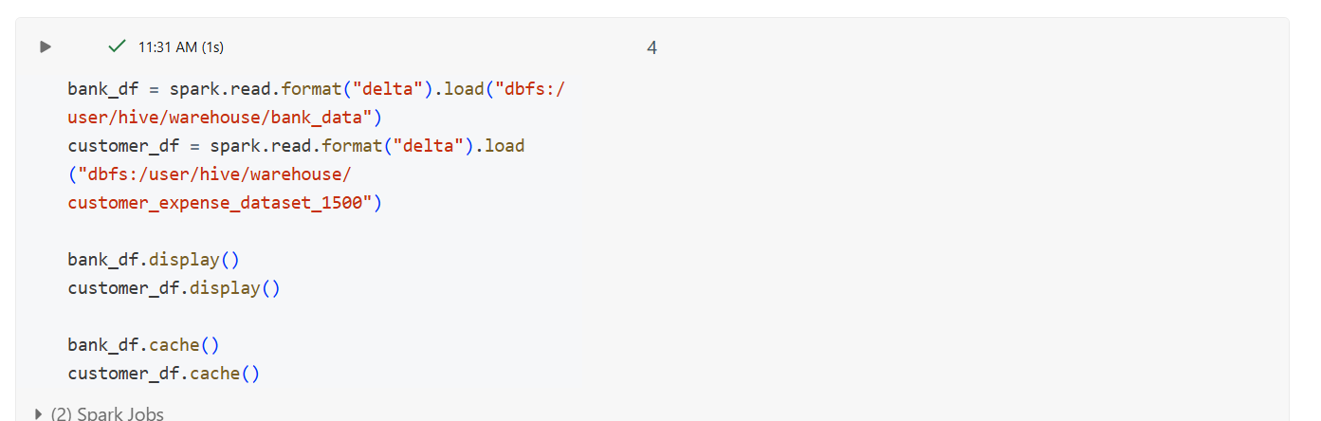

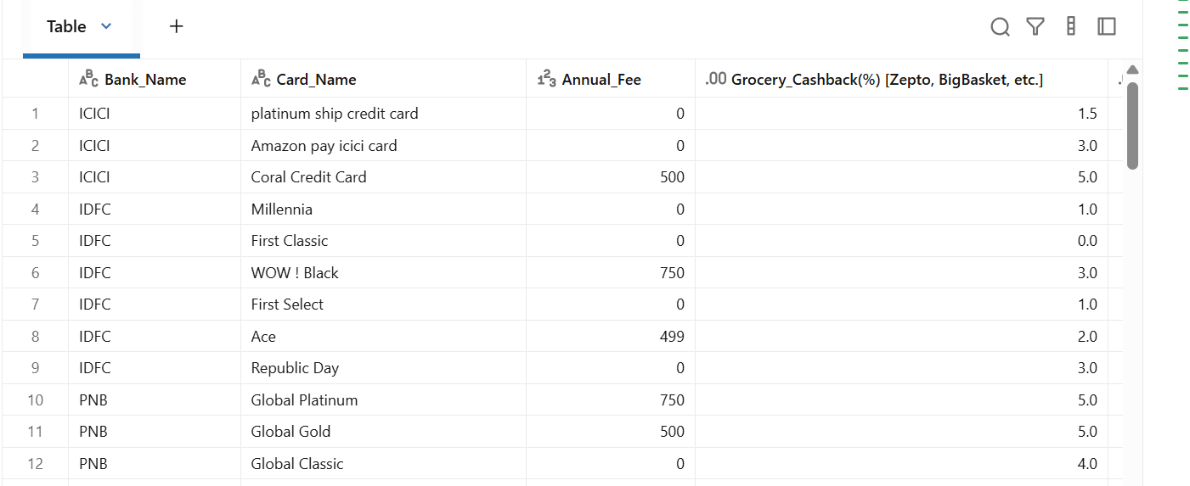
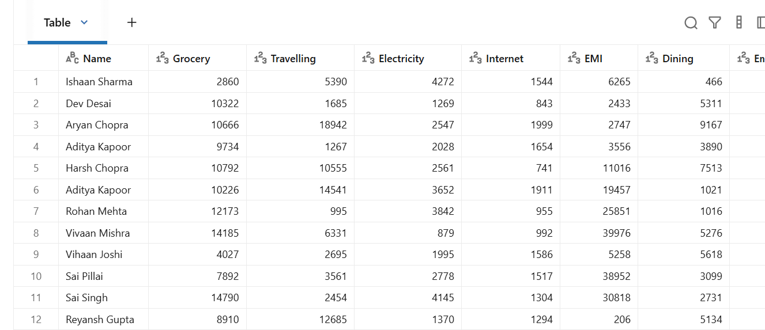

Use Cases
Here are 10 potential use cases that can be addressed using Python libraries like pandas
and numpy for data analysis:
1. Find the Best Credit Card for Grocery Shoppers
● Goal: Identify which credit card offers the highest cashback on grocery purchases (for
example, from Zepto, BigBasket, etc.) based on the available percentage in the dataset.
● Input: Customer's monthly grocery spending.
● Output: The best credit card(s) based on grocery cashback rate.

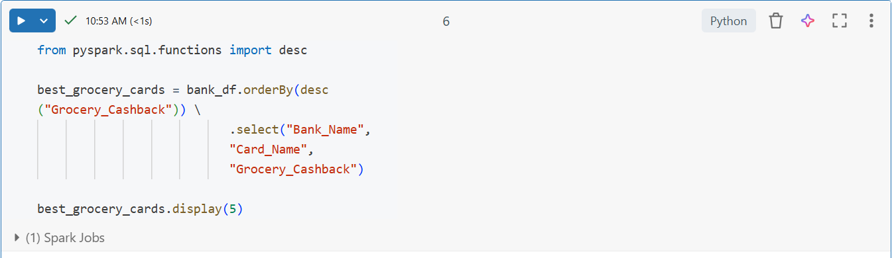
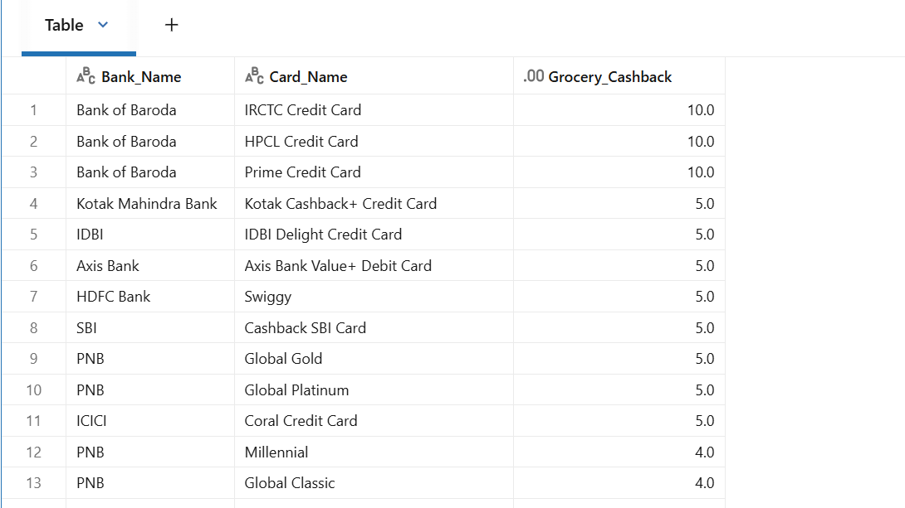

2. Identify Cards with No Annual Fee
● Goal: Filter out credit cards that do not have an annual fee and show them to customers
who prefer no upfront costs.
● Input: Annual fee data.
● Output: List of credit cards with zero annual fee.

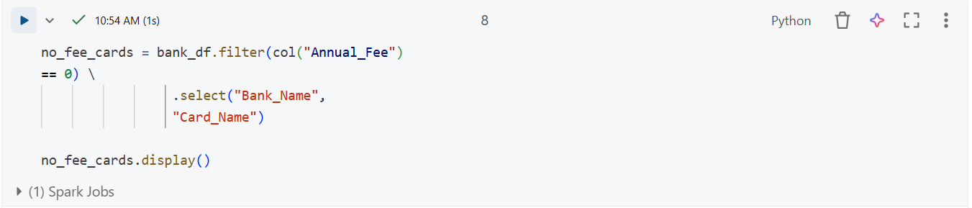

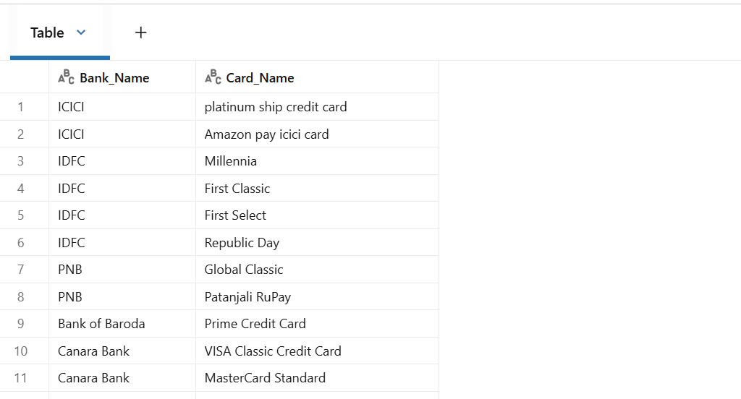

3. Match Customers with Cards Based on Income
● Goal: Identify credit cards that are available to a customer based on their income level.
● Input: Customer’s annual income.
● Output: List of credit cards the customer qualifies for based on their income.

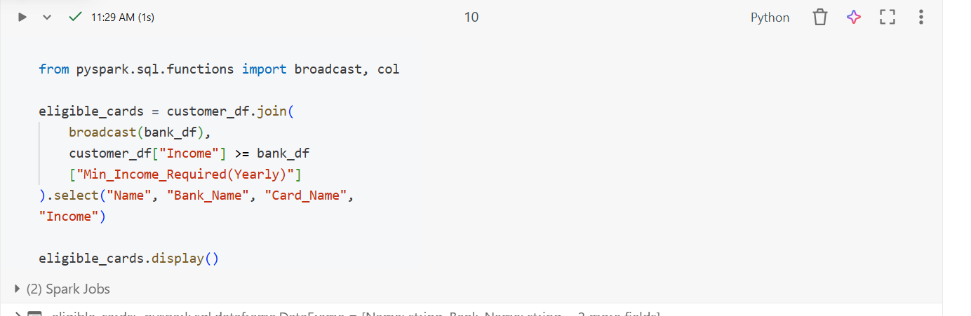

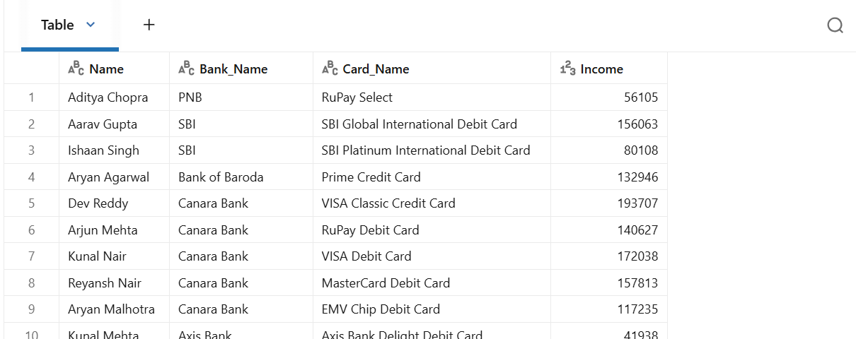

4. Calculate Total Cashback for Each Customer
● Goal: Calculate the total cashback a customer would receive based on their spending
across groceries, travel, and dining categories.
● Input: Customer's monthly spending in grocery, travel, and dining categories.
● Output: Total cashback value per credit card based on their spending.
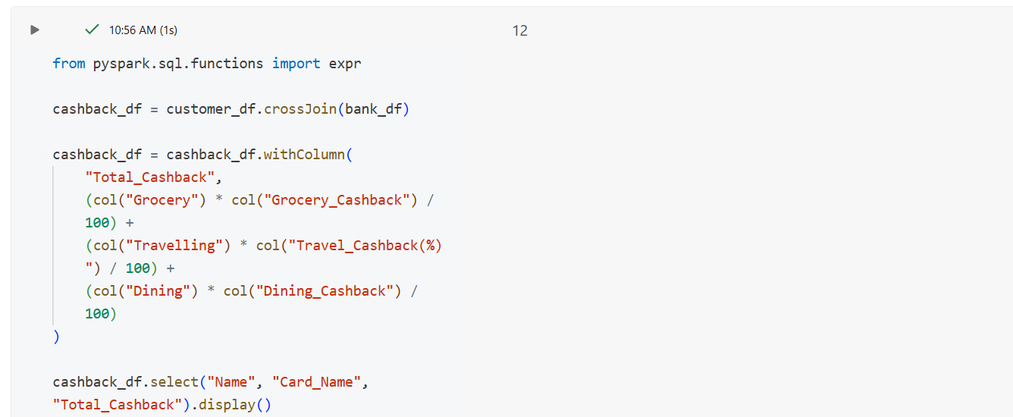

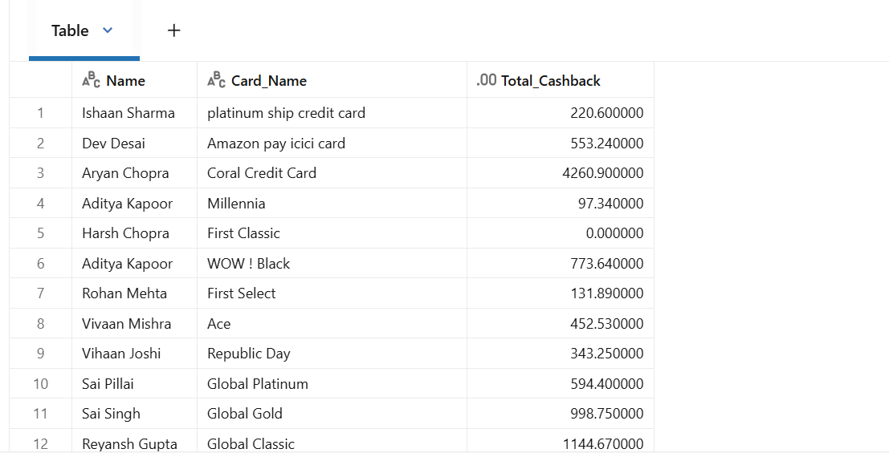

5. Identify Cards with Best Dining Cashback
● Goal: Find the credit cards that offer the highest cashback on dining (e.g., through
Swiggy, Zomato).
● Input: Customer’s monthly dining spending.
● Output: List of cards with the highest dining cashback percentage.

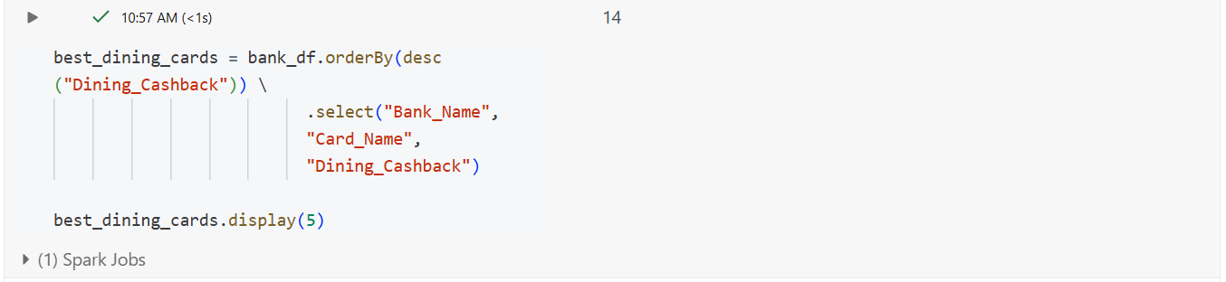
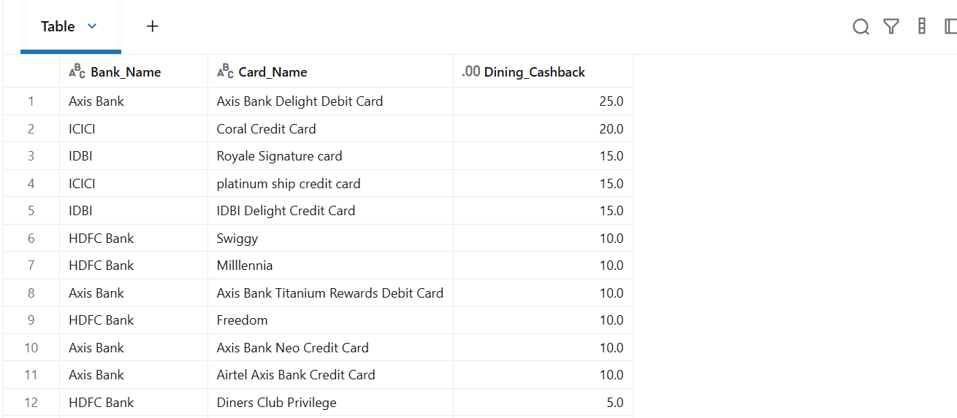

6. Card Comparison: Annual Fee vs. Cashback
● Goal: Compare the annual fee of credit cards with the total cashback value a customer
would get.
● Input: Customer's total annual spending in different categories.
● Output: List of cards with the best value when considering both the annual fee and
cashback.
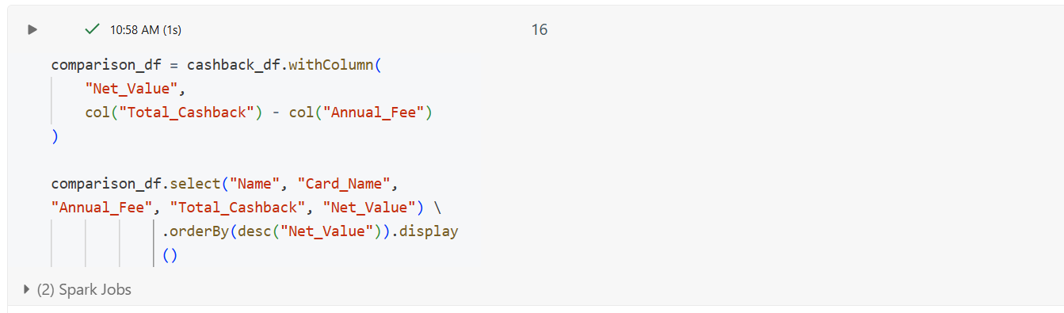
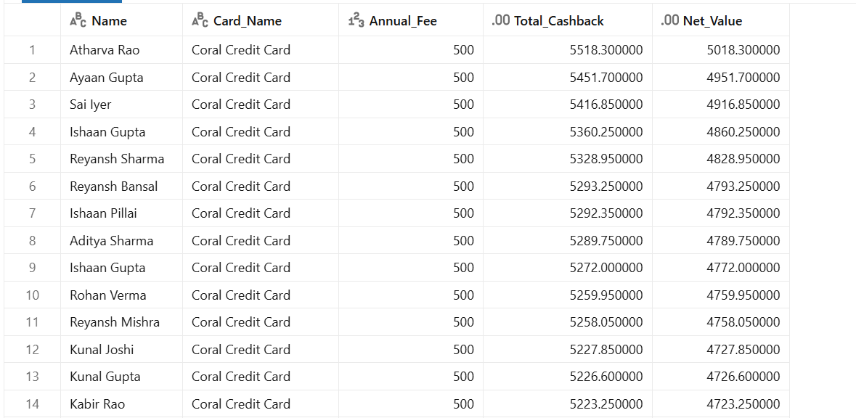

7. Filter Cards Based on Monthly Spending Limit
● Goal: Identify cards that offer a monthly spending limit suitable for the customer's
financial needs.
● Input: Customer’s desired monthly credit limit.
● Output: List of credit cards with monthly spending limits that match the customer’s
preferences.

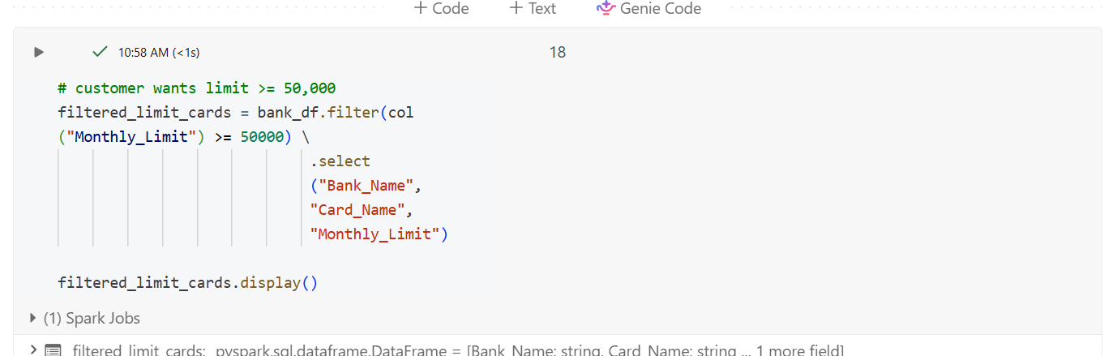
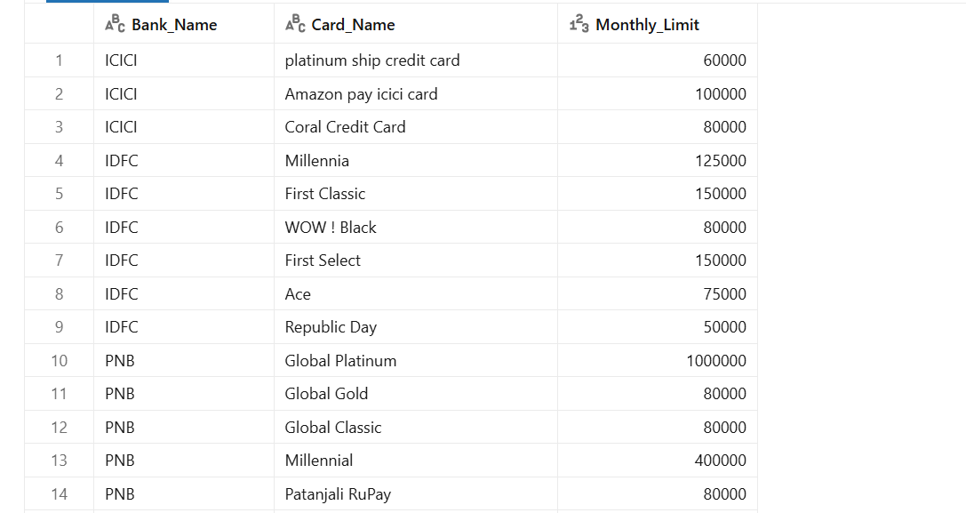

8. Find Cards with Highest Rewards Points
● Goal: Find credit cards that provide the highest reward points for every dollar spent.
● Input: Customer’s monthly expenditure across different categories.
● Output: List of credit cards offering the highest reward points.
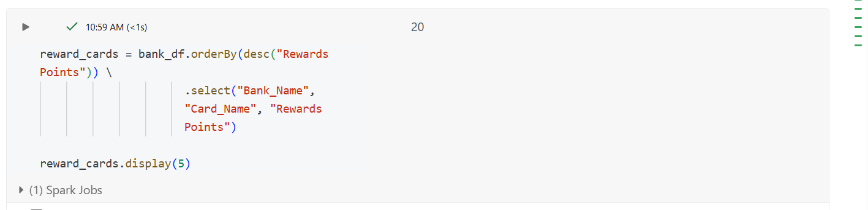
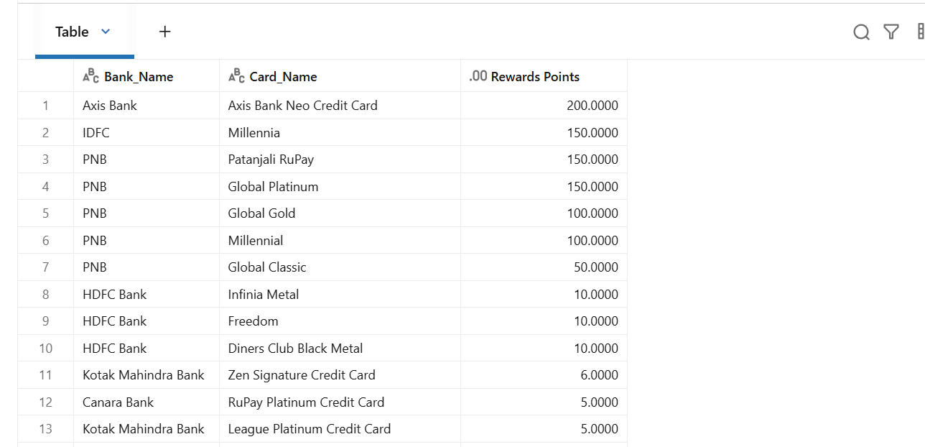

9. Lounge Access Preferences
● Goal: Identify credit cards that offer lounge access and match the customer's
preferences for travel benefits.
● Input: Customer’s travel habits and lounge access requirements.
● Output: List of credit cards with lounge access, categorized by frequency per year.

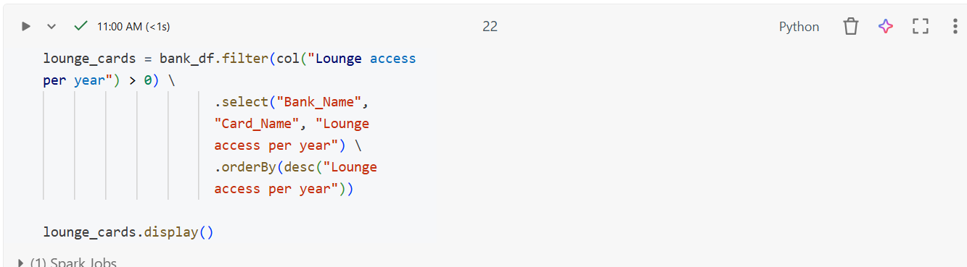

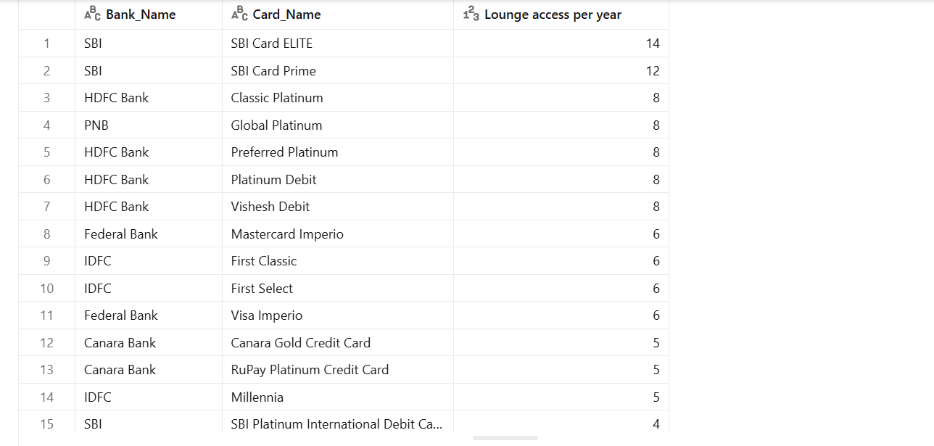
10. Customer-Specific Credit Card Recommendations
● Goal: Provide personalized credit card recommendations based on a customer’s profile,
which includes income, spending habits (grocery, dining, travel), and reward
preferences.
● Input: Customer’s annual income, monthly spending in different categories (grocery,
travel, dining), and rewards/benefits preference.
● Output: Recommended credit card(s) that align with the customer's needs.
Approach

